Shell Midden Landscapes from the Pacific and Atlantic Coasts of Canada
December 10th, 2019.

Meghan Burchell
Department of Archaeology
Memorial University of Newfoundland
mburchell@mun.ca

The biological and chemical analysis of shells from archaeological shell midden sites in Canada can provide new insights into past climate, sea surface conditions and long-term human-environmental interactions. High-resolution isotope sclerochronology permits a precise estimate for the season and intensity of shellfish harvesting, which is critical for interpreting past subsistence practices and landscape use. Current research in this topic has covered vast geographic regions in British Columbia, Nova Scotia and Labrador, spanning over 5000 years of occupation. The results of these studies are helping to change the way archaeologists interpret seasonal patterns of site occupation and mobility. Land use patterns by Indigenous peoples are not restricted to a single season, as previously thought, but rather encompasses a dynamic landscape that was used, and occupied year-round for centuries and millennia.

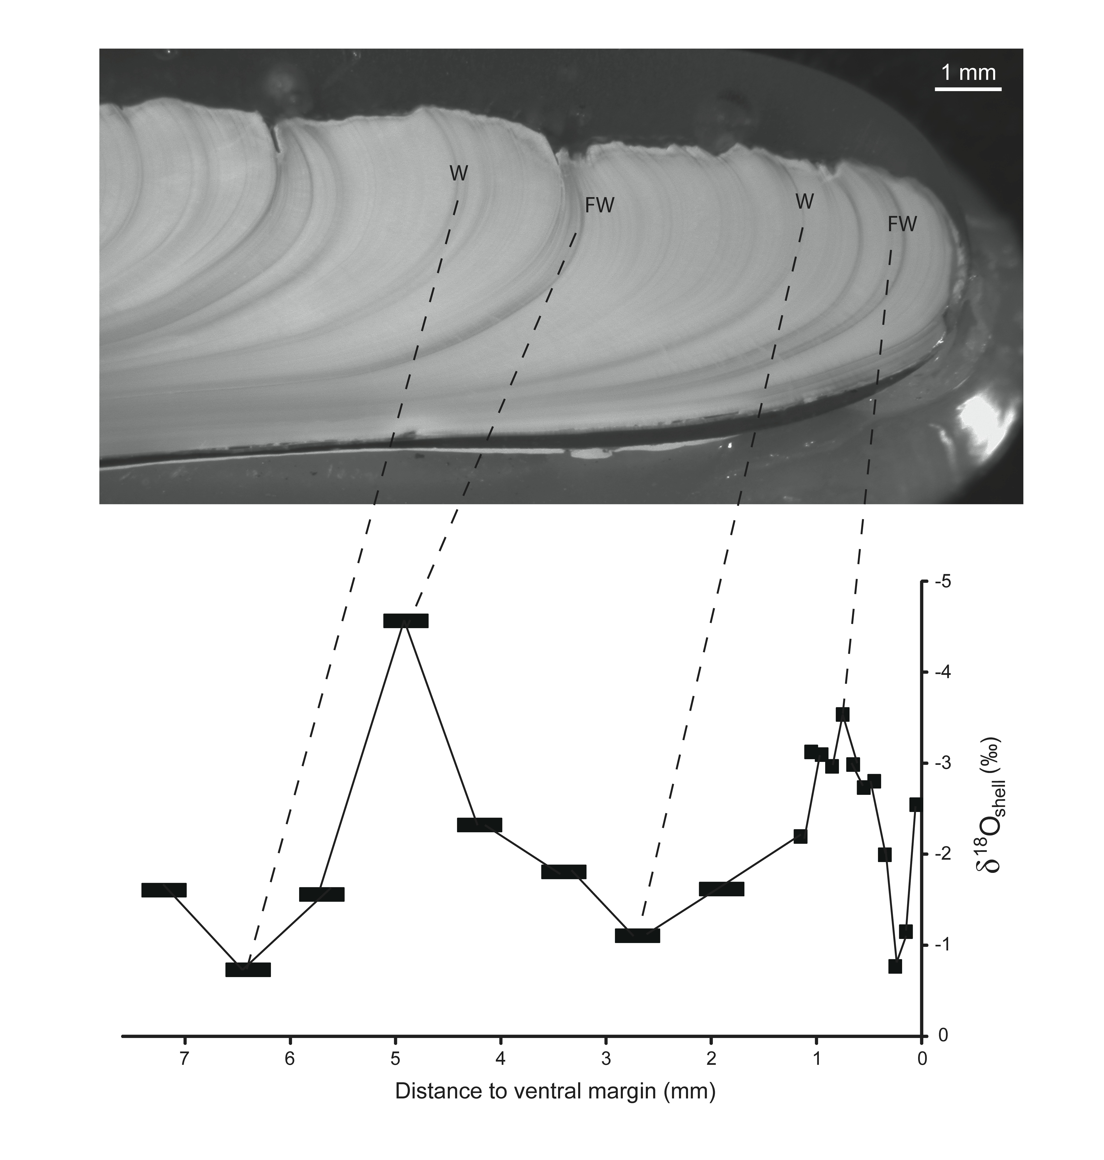

Stable oxygen isotope data aligned to periods of shell growth cessation associated with cold seasons and seasonal freshwater influxes. British Columbia, Canada

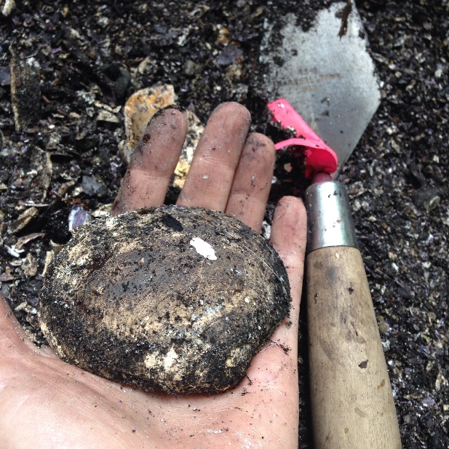

Saxidomus giganta (butter clam) recovered from a shell midden, Vancouver Island, British Columiba, Canada.

